OBJ programming taba

Student no. 20394073

Conn Fitzgerald

# Class diagram and test cases

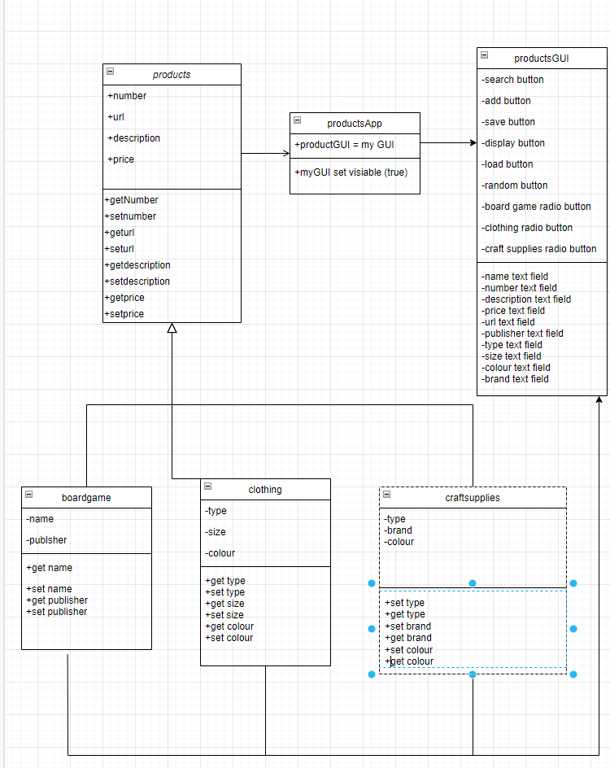

|  |  |  |  |  |  |  |
| --- | --- | --- | --- | --- | --- | --- |
| Test# | description | Test data | Expected result | Actual result | Pass/fail | comments |
| 1 | Adding and displaying to a board game | Name = monopoly  Number 123  Description = money  Price=16.99  URL = [www.monloply.com](http://www.monloply.com)  publisher = Hasbro | For it to print details entered |  | pass | works |
| 2 | Close the app then load | Load | To print last details saved |  | pass | works |
| 3 | Adding and displaying to clothing | Number 69  Description = Montclair  Price=430  URL = [www.monclare.com](http://www.monclare.com)  type= coat  size=L  colour=black | To print details |  | pass | All details printed |
| 4 | Adding and displaying to clothing | Number 300  Description = paper  Price=1.20  URL = [www.staples.com](http://www.staples.com)  type= paper  colour=white  brand=Arizona | It should print all details |  | pass | Printed correct details |
| 5 | Using random button | Random button | Should print a random bit of old information | Nothing happened | failed | Need to fix my random button |